LANDFILL LEACHATE TREATMENT BY BATCH SUPERCRITICAL WATER OXIDATION

TRATAMIENTO DE LIXIVIADOS DE RELLENO SANITARIO POR MEDIO DE OXIDACIÓN EN AGUA SUPERCRÍTICA

ABSTRACT
Landfill leachate treatment has been the focus of a great deal of research through different physicochemical and biological methods. Yet, no single method successfully addresses the required organic matter and nitrogen destruction efficiencies and common practice for handling this high strength wastewater involves the application of combined treatment technologies. Supercritical water oxidation (SCWO), a process that takes place at temperatures and pressures above the critical point of water and in the presence of a source of oxygen, has been successfully applied to the treatment of different types of wastewaters in an efficient way. Therefore, this paper presents an experimental study of the supercritical water oxidation of landfill leachate in a batch reactor in the temperature range 400-500°C, reaction times from 15 to 30 minutes and oxidant excess (OE) from 100% to 300%. Total organic carbon (TOC) and Total nitrogen (TN) destruction efficiencies were measured in the reactor effluent samples and the combined effect of the studied factors was analyzed by means of the Analysis of Variance (ANOVA). Optimal operation conditions for TOC destruction were 400°C, 30 min and 100% OE and 500°C, 30 min and 100% OE for TN. Different from what similar studies have reported, the results suggest it is possible to accomplish the simultaneous TOC and TN destruction in leachate wastewater by SCWO treatment at 400°C, 100% OE and residence times longer than 30 min and without using a catalyst, in batch or in a continuous mode operation, providing the oxidant and wastewater are mixed and heated up together, not separately, to reaction conditions.
Keywords: landfill leachate, SCWO, TOC destruction, Total Nitrogen destruction
RESUMEN
El tratamiento de lixiviados por medio de diferentes procesos fisicoquímicos y biológicos ha sido ampliamente estudiado. Sin embargo, ningún proceso logra las eficiencias de destrucción requeridas en cuanto a materia orgánica y nitrógeno, razón por la cual el tratamiento se realiza por medio de tecnologías combinadas. La oxidación en agua supercrítica o SCWO, proceso que se lleva a cabo a temperaturas y presiones superiores a las del punto crítico del agua en presencia de una fuente de oxígeno, se ha aplicado exitosamente al tratamiento de distintos tipos de aguas residuales de forma eficiente. Por lo tanto, este trabajo presenta un estudio experimental de la oxidación en agua supercrítica de lixiviados de relleno sanitario en un reactor batch, en el rango de temperatura de 400-500°C, tiempos de reacción de 15 a 30 minutos y excesos de oxígeno (OE) de 100% a 300%. Se midieron las eficiencias de destrucción de carbono orgánico total (COT) y nitrógeno total (NT), y se determinó el efecto combinado de los factores estudiados por medio del Análisis de Varianza (ANOVA). Las condiciones de operación óptimas para la destrucción de COT fueron 400°C, 30 min and 100% OE y 500°C, 30 min and 100% OE para NT. A diferencia de lo reportado en estudios similares, los resultados sugieren que es posible llevar a cabo la destrucción simultánea del COT y NT en los lixiviados por medio de SCWO a 400°C, 100% OE and tiempos de residencia de más de 30 min sin usar un catalizador, ya sea en un proceso batch o continuo, siempre y cuando tanto el oxidante como el agua residual se mezclen y calientes juntos a la temperatura de reacción.
Palabras clave: lixiviados, SCWO, destrucción COT, destrucción de nitrógeno total

INTRODUCTION
Landfill leachate is the wastewater resulting of the degradation of wastes organic fraction in combination with percolation of rainwater through municipal solid waste landfills [1]. Due to different biochemical processes that take place as a result of the stabilization of the organic matter in the waste pile, landfill leachate is heavily contaminated with organic matter and ammonia nitrogen from the ammonification of organic nitrogen, heavy metals as well as other toxic and priority pollutants. Environmental impacts caused by wastewater of such characteristics, associated to the depletion of oxygen and eutrophication in receiving surface and ground waters, are well documented [2]. Therefore, an efficient wastewater treatment for landfill leachate must abate not only the organic matter load but also nitrogen and heavy metals, irrespective of the variations in volumetric flow and composition.
In this aspect, landfill leachate treatment continues to be an area of intense research by different physicochemical, biological and emerging methods. Yet, no single technology claims to handle this heavily polluted residue in an efficient way or in compliance with the most stringent regulations without operational constrains that limit in one way or another its practical application. Several authors have extensively reviewed the advantages and drawbacks of conventional as well as emerging leachate treatment process by means of leachate transfer, biodegradation, physical and chemical methods and membrane processes [1,3]. It is evident from these thorough reviews that the application of the conventional physicochemical and biological treatment technologies to leachate treatment is hindered not only by insufficient chemical oxygen demand (COD) and nitrogen removal efficiencies, but also for operational constraints such as the age of the leachate in the case of anaerobic biological processes, excessive sludge production, ammonia inhibition and energy expenditure in aerobic biological processes, and sludge production and chemicals consumption in the case of physicochemical processes. With only a few exceptions, COD removal efficiencies vary from poor to moderate, and ammonia nitrogen, recalcitrant compound and considered the rate limiting step in the total mineralization of organic matter [4,5], is scarcely addressed.
In lieu of the potential impact that can be associated to ammonia nitrogen and heavy metals in the environment, an all-around leachate treatment process should be assessed not only from the organic matter removal, measured as COD, BOD or TOC reduction, but also ammonia nitrogen and heavy metals abatement through a single process system, not easily affected by variations in the waste chemical composition, nor requiring any additional pretreatment operations such as pH conditioning or ammonia stripping, and not producing an additional byproduct to be further dealt with, such as biological sludge and gases, as occurs in biological treatment processes [1,6]. All of these criteria could be satisfied by a process known as supercritical water oxidation or SCWO, an advanced oxidation process that takes advantage of the fascinating properties of supercritical water as a reaction media at conditions of temperature and pressure higher than the critical point of water (374 °C and 22.1 MPa). At these conditions, and as a result of the loss of hydrogen bonding, water is completely miscible with organic compounds and oxygen, which makes possible to carry out rapid oxidation reactions in a single phase media at very high temperature without mass transfer limitations. SCWO has been successfully applied to the treatment of different kinds of persistent and anthropogenic wastes, characterized by a high chemical oxygen demand (COD) and also the presence of heavy metals, which cannot be efficiently or economically handled by conventional waste treatment technologies such as incineration. Leachate treatment by supercritical water oxidation has been recently reported by several groups using either continuous or batch processes. Weijin and Xuejun [7] studied a landfill leachate treatment process using a continuous system with a transpiring-wall reactor (TWR). In this study, diluted leachate and excess oxidant were fed to the reaction system. COD removal efficiencies were higher than 97% at 430 °C and 30 MPa. Alternatively, Wang et al. [8] studied the supercritical water oxidation of landfill leachate with a special focus on ammonia in a batch reactor, at temperatures 380-500 °C, reaction time of 50-300 s, oxygen excess (OE) from 100 to 450% and pressure of 25 MPa, with and without MnO₂ as a catalyst. Through a response surface analysis, it was shown that NH₃ and COD conversions were low at temperatures near 400 °C and short reaction times. Zou et al. [9] studied the co-destruction of organic pollutants in leachates and dioxins in fly ash from leachates incineration by means of supercritical water oxidation in a batch reactor at different temperatures from 400-500 °C, OE from stoichiometric to 300% and RT of 1 and 2 min. Similar conclusions to those reported by Wang et al. [8], with a maximum COD conversion of 99.2% at 500°C, 300% OE and 2 min and PCDD/F degradation efficiency >90%, were reported. Nitrogen was not addressed in this study.
A leachate treatment process based on SCWO technology could improve on existing physicochemical and biodegradation processes in aspects such as the organic matter and ammonia-nitrogen conversion, as well as the absence of a sludge that needs further treatment. Yet, in order to assess the feasibility of the scale-up of the process to an industrial level, additional experiments should be conducted to elucidate the effect of the different variables in the leachate treatment by SCWO, in such a way that the lab scale experiments give insights on a feasible pilot plant operation. Accordingly, the batch SCWO of landfill leachate with hydrogen peroxide is reported in this work. Process performance is assessed by means of a factorial experimental design. Individual factors and its interactions in Total organic Carbon (TOC) and Total Nitrogen (TN) destruction efficiencies were analyzed.

1. MATERIALS AND METHODS
1.1 Experimental apparatus
SCWO experiments were carried out in a batch reactor made of ½” (1.27 cm) OD Swagelok tubing and fittings, 0.17 cm wall thickness, and 25 cm length for a total volume of 16.98 cm³. The reactor withstands a maximum pressure of 35 MPa at 500 °C (773 K). A PID temperature controller oven (± 2°C) was used to carry out the experiments.

1.2 Material and analytical methods
Landfill leachate was collected from a sanitary landfill located in the city of Villavicencio in Colombia, in a WWTP affluent sampling port. Hydrogen peroxide (H₂O₂) 30 wt% solution (Merck) was used as the oxidant. Total organic carbon (TOC) and total nitrogen (TN) were measured before and after SCWO treatment following adapted methods corresponding to standardized methods 5310D for TOC in a DR 3800 Hach Spectrophotometer and TN_{b} 220 for organically and inorganically bound nitrogen in a Macherey-Nagel nanocolor Vario 4 Spectrophotometer. TOC is considered more convenient than BOD or COD due to the presence of organic carbon that does not respond to either of these methods. Total Nitrogen is the sum of nitrate-nitrogen (NO₃-N), nitrite-nitrogen (NO₂-N), ammonia-nitrogen (NH₃-N) and organically bonded nitrogen. Several authors have shown that nitrate and nitrite nitrogen can be formed in SCWO. Therefore, TN is more representative of nitrogen fate in SCW than Total Kjeldahl Nitrogen (TKN), which has into account only ammonia and organic nitrogen.

Total organic carbon and total nitrogen destruction efficiencies were defined according to Eqs. (1) and (2):
$X_{TOC}=\frac{{TOC}_{i}−{TOC}_{f}}{{TOC}_{i}}$ (1)
$X_{TN}=\frac{{TN}_{i}−{TN}_{f}}{{TN}_{i}}$ (2)

Where TOC_{i} and TN_{i} are the initial concentration of total organic carbon and total nitrogen in the leachate after the dilution with 30 wt% hydrogen peroxide solution and TOC_{f} and TN_{f} are the corresponding concentrations in the reactor effluent.
1.3 Experimental procedure
TOC and TN were measured in the raw landfill leachate sample as 8700 mg/L and 2800 mg/L, respectively. In a typical experimental run, a given amount of undiluted leachate was mixed with a volume of 30 wt% hydrogen peroxide solution, according to the amount of oxidant excess and having into account the reactions for hydrogen peroxide decomposition in SCW [10] and TOC oxidation:

$H_{2}O_{2}→H_{2}O+\frac{1}{2}O_{2}$ (3)
$C+O_{2}→{CO}_{2}$ (4)
Accordingly, oxygen excess (OE) was defined as in Eq (5):
$OE=\frac{\left[O_{2}\right]}{{\left[O_{2}\right]}_{stoich}}×100\text{\%}$ (5)
Where $\left[O_{2}\right]$ is the provided initial concentration of O₂ from the decomposition of the added hydrogen peroxide according to the decomposition reaction and ${\left[O_{2}\right]}_{stoich}$ is the calculated stoichiometric amount of O₂, according to Eq (4), required to completely oxidize the organic matter measured as TOC. Calculated oxidant solution requirement based on this approximation is considerably lower than that resulting from the most widely used COD measurement. The exact mass of leachate-oxidant solution to be injected in the reactor is determined based on the specific volume of water at reaction conditions calculated by means of the Peng-Robingson Equation of State (PR-EOS) and the volume of the reactor. The reactor is placed in the oven, previously heated at reaction conditions, and left for a specific reaction time. Once the reaction time is finished, the reactor is removed from the oven and immersed in a cold water bath to stop the reaction. Liquid effluent is collected for TOC and TN analysis. No attempt was made to collect the gaseous phase at this stage of the research.
1.4 Statistical analysis
Experimental runs were planned according to a replicated twice 2^{k} full factorial design with factors temperature (A), reaction time (B) and oxygen excess (C), using TOC and TN as response variables. Low and high levels for each factor (-1,+1) were selected according to preliminary experiments as well as practical considerations regarding reactor construction materials and hydrogen peroxide consumption. Thus, levels for temperature were 400 and 500 °C, 15 and 30 min reaction time and oxygen excess of 100 and 300%. With four repetitions in the central point (450 °C, 22.5 min, and 200% OE) the full design is comprised by 20 experimental runs, made in randomized order. Statistical analysis of the results was made according to the analysis of variance (ANOVA) on both response variables, as well as the graphical analysis of the significant main effects and interactions plots, by using the statistical software package Minitab.

2. RESULTS AND DISCUSSION
The summary of reaction conditions, initial and final TN and TOC concentrations and destruction efficiencies is shown in Table 1, in which T is the reaction temperature and Time is the total reaction time. Runs are identified and shown according to the label in the 2^{k} experimental design and the order in which each run was carried out. Similar figures obtained for TOC and TN destruction efficiencies in the four central points and the two replicates for each treatment condition indicate the statistical reproducibility of the whole experiment was generally good. For all the treatment conditions in the experimental design, TOC destruction efficiencies were higher than 70%, whereas TN destruction efficiencies were lower, with efficiencies higher than 30%. Maximum destruction efficiency for TOC was 99.5% at 400°C, 30 min reaction time and 300% OE, whereas for TN was 92.2% at 500°C, 30 min and 100% OE. These results suggest the organic matter in the leachate can be effectively oxidized at 400°C. However, nitrogen abatement might require a more aggressive treatment at 500 °C. An analysis of variance (ANOVA) of the experimental data was carried out in order to elucidate the joint effect of the factors and its interactions on the response, so that a more general conclusion regarding the optimal set of operation conditions can be drawn. ANOVA for TOC and TN destruction efficiencies is discussed next.
Table 1. Summary of reaction conditions, initial and final TOC and TN
concentrations and destruction efficiencies
Run-  label | T  (°C) | Time (min) | OE (%) | TN_{i}  (mg/L) | TN_{f} (mg/L) | X_{TN}  (%) | TOC_{i} (mg/L) | TOC_{f} (mg/L) | X_{TOC}  (%)
1 - ab | 500 | 30 | 100 | 2187.5 | 170 | 92.2 | 6797 | 910 | 86.6
2- 0 | 450 | 22.5 | 200 | 1971.9 | 920 | 53.3 | 6127 | 940 | 84.7
3-abc | 500 | 30 | 300 | 1794.9 | 420 | 76.6 | 6127 | 940 | 83.2
4-(1) | 400 | 15 | 100 | 2187.5 | 1470 | 32.8 | 6797 | 1970 | 71.0
5-bc | 400 | 30 | 300 | 1794.9 | 560 | 68.8 | 5577 | 200 | 96.4
6-abc | 500 | 30 | 300 | 1794.9 | 220 | 87.7 | 5577 | 1170 | 79.0
7-c | 400 | 15 | 300 | 1794.9 | 1170 | 34.8 | 5577 | 1980 | 65.0
8-(1) | 400 | 15 | 100 | 2187.5 | 1360 | 37.8 | 6797 | 1970 | 71.0
9-ac | 500 | 15 | 300 | 1794.9 | 840 | 53.2 | 5577 | 550 | 82.6
10-a | 500 | 15 | 100 | 2187.5 | 1280 | 41.5 | 6797 | 1220 | 83.0
11-ac | 500 | 15 | 300 | 1794.9 | 660 | 63.2 | 5577 | 970 | 82.6
12-0 | 450 | 22.5 | 200 | 1971.9 | 700 | 64.5 | 6127 | 600 | 90.2
13-0 | 450 | 22.5 | 200 | 1971.9 | 830 | 57.9 | 6127 | 1470 | 76.0
14-b | 400 | 30 | 100 | 2187.5 | 870 | 60.2 | 6797 | 1210 | 98.2
15-bc | 400 | 30 | 300 | 1794.9 | 380 | 78.8 | 5577 | 30 | 99.5
16-ab | 500 | 30 | 100 | 2187.5 | 460 | 79.0 | 6797 | 1460 | 78.5
17-C | 400 | 15 | 300 | 1794.9 | 1130 | 37.0 | 5577 | 1960 | 64.9
18-0 | 450 | 22.5 | 200 | 1971.9 | 530 | 73.1 | 6127 | 1420 | 76.8
19-b | 400 | 30 | 100 | 2187.5 | 540 | 75.3 | 6797 | 550 | 91.9
20-a | 500 | 15 | 100 | 2187.5 | 1190 | 45.6 | 6797 | 750 | 89.0

2.1 Total organic carbon ANOVA
According to the TOC normal plot of stardardized effects shown in Fig. 1, factor B and the interaction AB have significant effect on the response. The model had a regression coefficient R²= 88.39%. Since A, C, BC, AC and ABC terms are insignificant, the design was re-analyzed dropping these terms from the model. The normal probability plot of the residuals and residuals vs fitted values or constant variace plot for the re-analyzed design are shown in Figs. 2 and 3.

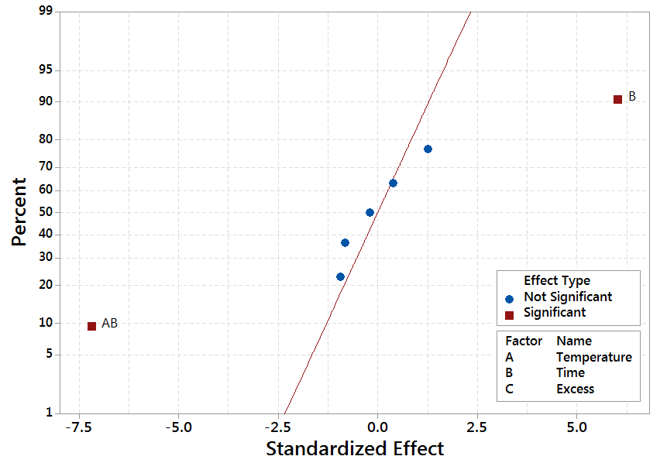
Fig. 1. TOC normal plot of standardized effects (α=0.05)

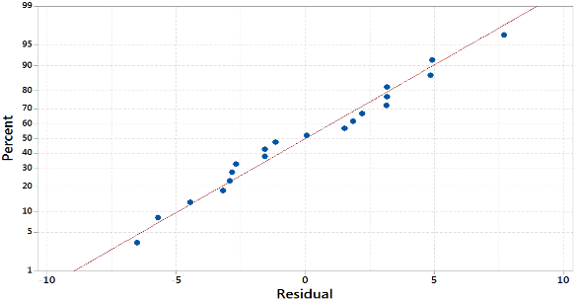
Fig. 2. Normal probability plot of the residuals

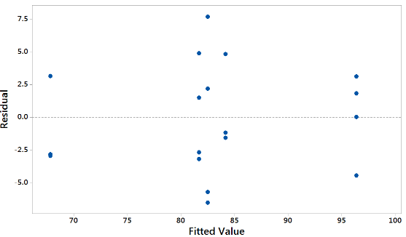
Fig. 3. TOC Constant Variance plot of the residuals

As can be observed in Fig. 2, the normal probability plot of the residuals resembles a straight line, therefore the error distribution is normal. In a similar way, Fig. 3 shows a random patter of the residuals on both sides of 0, without any recognizable patterns. Therefore, the model is correct and the assumptions were satisfied. ANOVA for the re-analyzed model is summarized in Table 2.

Table 2. ANOVA for TOC destruction efficiency
Source of Variation | Degrees of freedom | Sum of squares | Mean square | F_{o} | P-value
Model | 3 | 1642.3 | 547.4 | 31.0 | 0.0
Linear | 2 | 681.3 | 340.7 | 19.3 | 0.0
Temperature | 1 | 2.7 | 2.7 | 0.2 | 0.7
Time | 1 | 678.6 | 678.6 | 38.5 | 0.0
2-Way Interactions | 1 | 961.0 | 961.0 | 54.5 | 0.0
Temperature*Time | 1 | 961.0 | 961.0 | 54.5 | 0.0
Error | 16 | 282.2 | 17.6
Lack-of-Fit | 5 | 60.4 | 12.1 | 0.6 | 0.7
Pure Error | 11 | 221.8 | 20.2
Total | 19 | 1924.5

According to the P-values in the ANOVA for TOC destruction efficiency in Table 2, the model has a P-value of 0.0. In a similar way, the main effects of reaction time (B) and the interaction AB of temperature and reaction time are highly significant, with P-values < 0.01. According to Montgomery [11], the main effects do not have much meaning when there are involved significant interactions. While the positive effect estimate for B effect suggest working at the high level of the reaction time to increase the TOC destruction efficiency, AB interaction might indicate differently. AB interaction plot is shown in Fig. 4.
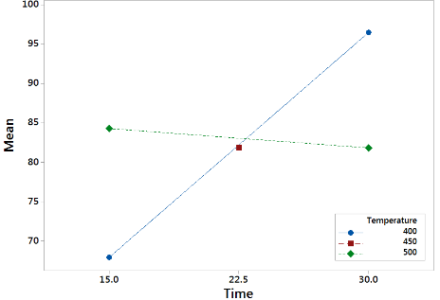
Fig. 4. Temperature-time (AB) interaction
Fig. 4 shows the effect of time is significant when working at 400°C and negligible when working at 500°C. The higher reaction temperature speeds up the reaction and as a result the TOC mean destruction efficiencies are similar at 15 and 30 minutes. However, TOC mean destruction efficiencies are higher when working at 400°C and 30 min reaction time. Usually, SCWO experimental studies report a positive effect of temperature when working in a continuous unit set up and with residence times of a few seconds. Yet, the heating time of the substance to oxidize and the oxidant agent, pumped separately, is not accounted for. From Fig. 4 can be concluded that the optimal operation conditions for TOC destruction are 400 °C, 30 min reaction time and 100% oxygen excess since this factor was not significant. However, factors effect on TN destruction could be different and suggest a different set of operation conditions. TN ANOVA is discussed next.
2.2 Total nitrogen ANOVA
TN normal plot of stardardized effects is shown in Fig. 5. The model had a P-value of 0.0 and a R² value of 90%. Main factors A and B, temperature and time, have significant effect on nitrogen abatement, with P-values for temperature and time of 0.001 and 0, respectively. Different from what was observed for TOC destruction, no interactions are significant for TN. Accordingly, the design was re-analyzed dropping the terms C, AC, BC, AB and ABC from the analysis. The results are shown in Figs. 6 and 7. Normal probability plot resembles a straight line and residuals show a random pattern around 0, therefore, there is no reason to suspect any problems with the validiy of the conclussions [11]. TN temperature and time main effects plot is shown in Fig. 8.

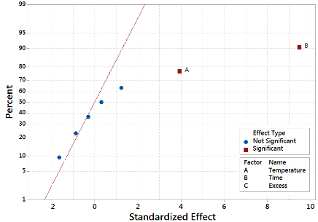
Fig. 5. TN normal plot of stardardized effects (α=0.05)
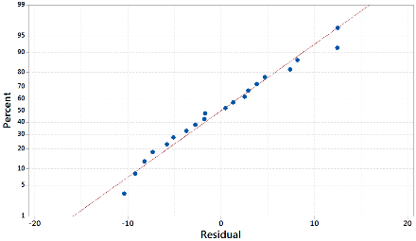
Fig. 6. TN normal probability plot of the residuals
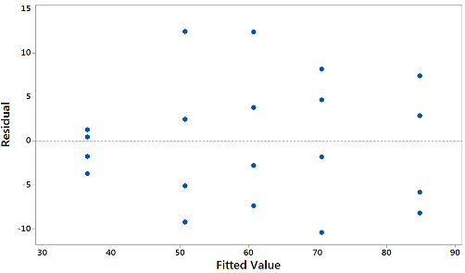
Fig. 7. TN Constant Variance plot of the residuals

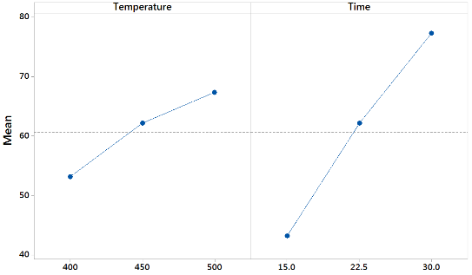

Fig. 8. TN temperature and time main effects plot

Fig. 8 shows the temperature and time effects are positive, which suggest the optimal operation conditions are 500 °C, 30 min reaction time and 100% oxygen excess. Although temperature effect was found insignificant for TOC destruction when working at residence times longer than 15 min, ammonia-nitrogen (NH₃-N), formed as a stable intermediate compound in the oxidation of nitrogen containing components, is a well-known recalcitrant compound and usually requires temperatures higher than 600 °C in the SCWO process [12-16]. In fact, it has been suggested the ammonia oxidation to nitrogen or nitrous oxide is the rate limiting step in the global oxidation [4,5]. At 400°C, 30 min and OE of 100%, optimal operation conditions for TOC destruction, average TN destruction of runs 14 and 19 is 68%. This figure is higher than the 46.9% ammonia conversion reported by Wang et al. [8] in the SCWO of leachate at 400°C, OE of 350% and 300 s reaction time, with a heating velocity of 4.07 °C/min in absence of the oxidant. The difference could be attributed to the experimental procedure followed in this work, in which the leachate and oxidant were mixed and heated up to reaction conditions and left for a specific time, instead of heating up the leachate to the desired reaction temperature before injecting the oxidant, which could cause pyrolysis of the organic compounds. Temperature-time contour plots for TOC and TN destruction efficiencies are shown in Fig. 9. As was shown in TOC ANOVA, the temperature-time significant interaction causes the TOC destruction efficiency contour plots to curve when temperature goes from low (400°C) to high (500°C), whereas TN contour plots are straight due to the absence of significant interactions and TN destruction efficiency increases with temperature and time. Although high TN destruction efficiency can be obtained at 500°C, as shown in TN contour plots and also suggested by other works [8], Fig. 8 suggest a reaction time longer than 30 min could increase TN destruction efficiency. Therefore, not only high TOC but also TN destruction efficiency could be obtained working at 400°C, OE of 100% and reaction times longer than 30 minutes. From a scale-up point of view, a reaction temperature of 400°C is more desirable than 500°C due to increased cost of equipment construction materials and also the higher energy consumption expected when working at 500°C. Even though the results were obtained in a batch reactor, the implemented experimental procedure of mixing the leachate and oxidant and heating up to reaction conditions would be similar to the operation of a continuous unit in which the leachate-oxidant mixture is pumped through preheaters up to the reaction temperature and kept constant for a residence time similar to those found in this study.

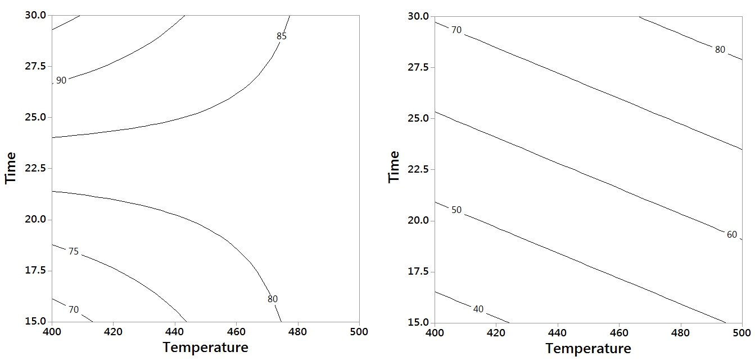
Fig. 9. Temperature-time Contour plots for TOC (left) and TN (right) destruction efficiency

4. CONCLUSIONS

This work reports the SCWO of landfill leachate in a batch reactor system in which the joint effect of temperature, time and oxygen excess were assessed by means of a factorial experimental design. ANOVA for TOC and TN destruction efficiency showed the temperature-time interaction was significant for TOC destruction efficiency and the interaction plot showed the optimal operation conditions for TOC destruction were 400°C, 30 min and 100% OE. Temperature and time factors were significant for TN destruction efficiency, which were higher than those reported by other works at similar reaction conditions. Main effect plots showed the optimal operation conditions were 500°C, 30 min and 100% OE. Although higher temperature is required for TN destruction, contour plots showed an even longer reaction time could increase TN destruction efficiencies while keeping the reaction temperature at 400°C, a more desirable reaction temperature from a scale-up point of view.

REFERENCES

[1] Kurniawan, T.A., Lo, W.L., Chan, G., 2006. Physico-chemical treatments for removal of recalcitrant contaminants from landfill leachate. J. Hazard. Mater. 129 (1-3), 80-100.
[2] Chapra, S.C., 1997. Surface water quality modeling, McGrawHill, New York.
[3] Renou, S., Poulain, S., Givaudan, J., Moulin, P., 2008b. Treatment process adapted to stabilized leachates. Lime precipitation-prefiltration-reverse osmosis. J. Membrane Sci. 313 (1-2), 9-22.
[4] Webley, P.A., Tester, J.W., Holgate, H.R., 1991. Oxidation kinetics of ammonia and ammonia-methanol mixtures in supercritical water in the temperature range 530-700 °C at 246 bar. Ind. Eng. Chem. Res. 30 (8), 1745-1754.
[5] Bermejo, M., Cantero, F., Cocero, M., 2008. Supercritical water oxidation of feeds with high ammonia concentrations pilot plant experimental results and modeling. Chem. Eng J. 137 (3), 542-549.
[6] Renou, S., Givaudan, J., Poulain, S., Dirassouyan, F., Moulin, P., 2008a. Landfill leachate treatment: review and opportunity. J. Hazard. Mater. 150 (3), 468-483.
[7] Weijin, G., Xuejun, D., 2010, Degradation of landfill leachate using transpiring-wall supercritical water oxidation (SCWO) reactor, Waste Manage. 30 (11), 2103-2107
[8] Wang, S., Guo, Y., Chen, C., Zhang, J., Gong, Y. , Wang, Y., 2011. Supercritical water oxidation of landfill leachate. Waste Manage. 31 (9-10), 2027-2035.
[9] Zou, D., Chi, Y., Fu, C., Dong, J., Wang, F., Ni, M., 2013b. Co-destruction of organic pollutants in municipal solid waste leachate and dioxins in fly ash under supercritical water using H₂O₂ as oxidant, J. Hazard. Mater. 248-249, 177-184.
[10] Croiset, E., Rice, S.F., Hanush, R.G., 1997. Hydrogen peroxide decomposition in supercritical water, AICHE J. 43 (9), 2343-2352.
[11] Montgomery, D.C., 2012. Design and analysis of experiments, eighth ed., Wiley, New York.
[12] Killilea, W.R., Swallow, K.C., Hong, G.T., 1992. The fate of nitrogen in supercritical water oxidation, J. Supercrit. Fluid. 5 (1), 72-78.

[13] Helling, R.K., Tester, J.W., 1998. Oxidation of simple compounds and mixtures in supercritical water: carbon monoxide, ammonia and ethanol, Environ. Sci. Technol. 22 (11), 1319-1324.
[14] Ding, Z.Y., Li, L., Wade, D., 1998. Supercritical water oxidation of NH₃ over a MnO₂/CeO₂ catalyst. Ind. Eng. Chem. Res. 37 (5), 1707-1716.
[15] Benjamin, K.M., Savage, P.E., 2005. Supercritical water oxidation of methylamine. Ind. Eng. Chem. Res. 44 (14), 5318-5324.
[16] Ploeger, J.M., Madlinger, A.C., Tester, J.W., 2006. Revised global kinetic measurement of ammonia oxidation in supercritical water. Ind. Eng. Chem. Res. 45 (20), 6842-6845

